PIZZA SALES SQL QUERIES

A.KPI’s
1.Total Revenue
select sum(total_price) as total_revenue from `pizza_sales new`;
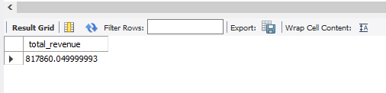

2.Average Order Value
select sum(total_price)/count(distinct order_id) as avg_order_value
from `pizza_sales new`;
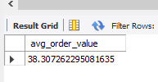

3.Total Pizza Sold
select sum(quantity) as total_pizza_sold
from `pizza_sales new`;
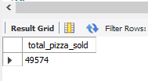

4.Total Order Placed
select count(distinct order_id) as total_order_placed
from `pizza_sales new`;
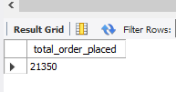

5.Average pizza per order
select sum(quantity)/count(distinct order_id) as avg_pizza_per_order
from `pizza_sales new`;
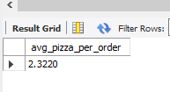

B. Daily Trend for Total Orders
select dayname(order_date) as order_day,
count(distinct order_id) as total_orders
from `pizza_sales new`
group by order_day
order by min(dayofweek(order_date));
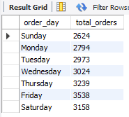
C.Hourly Trend for Total Orders
select hour(order_time) as order_hours,
count(distinct order_id) as total_orders
from `pizza_sales new`
group by hour(order_time)
order by hour(order_time);
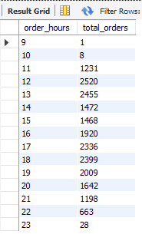
D.Percentage of sales by Pizza Category
select pizza_category,sum(total_price) as total_sales,
round(sum(total_price)*100/(select sum(total_price) from `pizza_sales new`),2)
as percentage_of_sales
from `pizza_sales new`
group by pizza_category
order by percentage_of_sales;
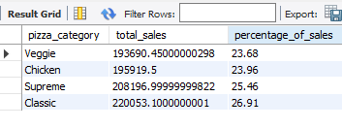
E.Percentage of sales by Pizza Size
select pizza_size,round(sum(total_price),2) as total_sales,
round(sum(total_price)*100/(select sum(total_price) from `pizza_sales new`),2)
as percentage_of_sales
from `pizza_sales new`
group by pizza_size
order by percentage_of_sales desc;
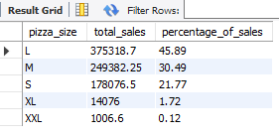
F.Total pizza sold by Pizza Category
select pizza_category,
sum(quantity) as total_pizza_sales
from `pizza_sales new`
group by pizza_category
order by total_pizza_sales desc;
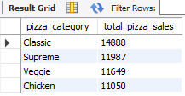
G. Top 5 best seller by total Pizza Sold
select pizza_name,
sum(quantity) as total_pizza_sold
from `pizza_sales new`
group by pizza_name
order by total_pizza_sold desc
limit 5;
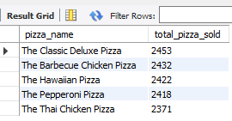

F.Top 5 wordt seller by Pizza Sold
select pizza_name,
sum(quantity) as total_pizza_sold
from `pizza_sales new`
group by pizza_name
order by total_pizza_sold asc
limit 5;
